## Inference Rules

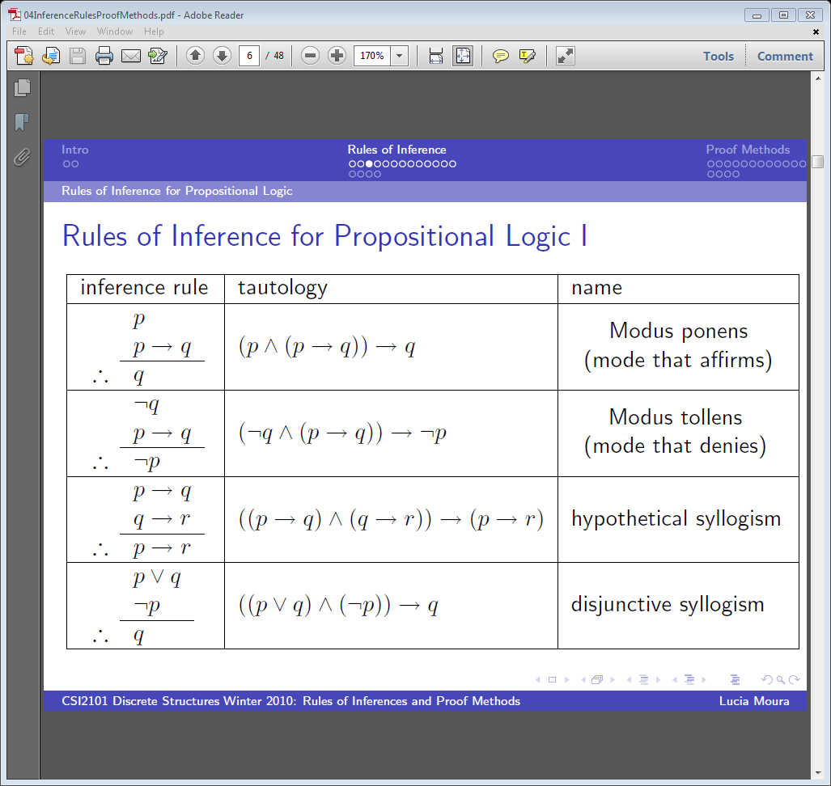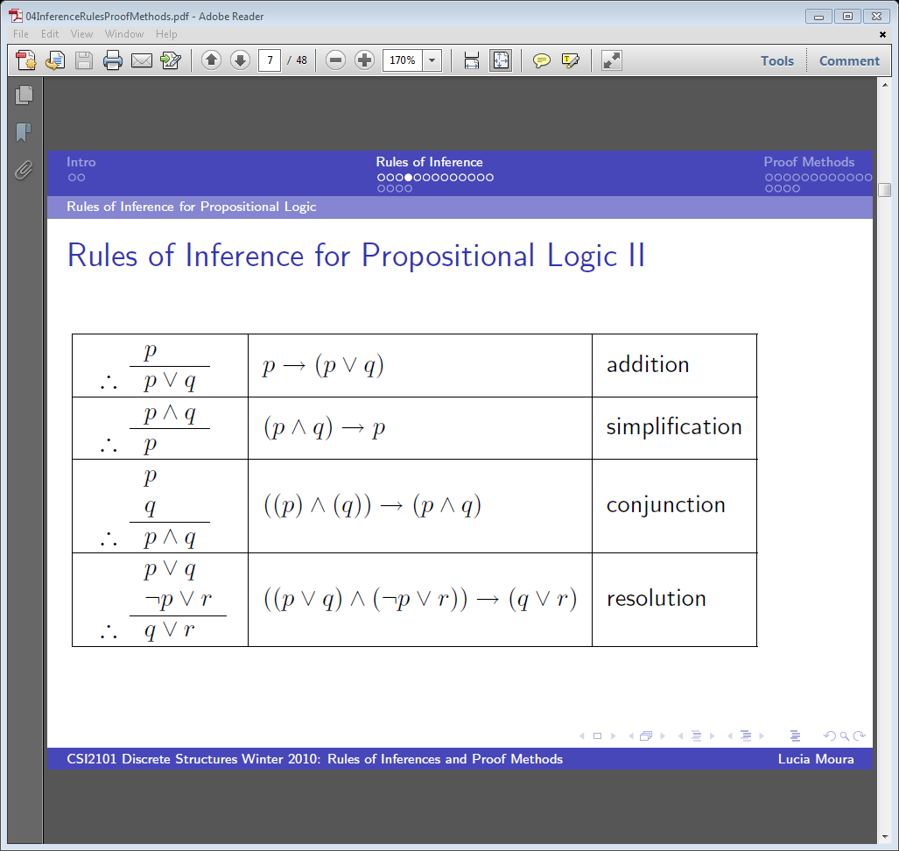

## Summary of the Proof by Contraposition indirect technique:

If you are trying to prove that $p←q$, it may not be easy to perform the direct proof. But since $¬q→¬p$ is the contrapositive (which is equivalent to the original implication), if the contrapositive can be proven, we know the original implication can be proven

CSCE 031 Day 4 Concept Test: PROOFS – Direct and Indirect Proof Practice

1. Use resolution to show that the hypotheses “Jasmine is s**k**iing or it is not s**n**owing” and “It is s**n**owing or Bart is playing **h**ockey” imply that “Jasmine is s**k**iing or Bart is playing **h**ockey”.

(k OR -n) AND (n OR h) --> (k OR h)

Equals: (n OR h) AND (k OR -n) -> (k OR h)

Because of resolution ((p OR q) AND (-p OR r)) 🡪 (q AND r) is true then this state is true.

If we know that it is either snowing or not snowing then it must be true that either Bart is playing hockey or Jasmine is skiing.

1. Prove the following conclusion using a direct proof from the premises. Include reasons (from rules for inference) for each step as you go. Premises: $P→Q$, $¬P→R$, $R→S$. Conclusion: $¬Q→S$.
2. Direct Proof: Show that if $m$ and $n$ are both perfect squares, then $nm$ is also a perfect square. Use the fact that an integer $a$ is a perfect square if there is an integer $b$ such that $a = b^{2}$.

.

1. Proof by Contraposition: Prove that if $n=ab$ (where $a$ and $b$ are positive integers) then $a≤\sqrt{n}$ or $b≤\sqrt{n}$.